Quin Rizer
Dr. Peter Nencka
ECO 311
5 May 2023
Understanding Urban Circulators: Did St. Louis’ Loop Trolley Raise Area Home Values?
- Introduction
In July 2020, the federal Transit Administration approved a plan to build a streetcar through St. Louis’ Delmar Loop neighborhood, located roughly twenty minutes from downtown. The Delmar Loop is a dense, walkable neighborhood containing restaurants, concert venues, shops, and apartments along its roughly mile long strip down Delmar Boulevard. Delmar Boulevard is infamous for being the namesake of the Delmar Divide, which is a sharp geographic barrier of disparate socioeconomic conditions. The trolley project, which would run through the neighborhood, and then turn south towards the St. Louis History Museum in Forest Park, was given over $50 million in the form of a grant from the Federal Transit Administration(FTA) with the goal to improve property values and advance economic development in the region. A trolley would hopefully allow individuals to get around the neighborhood faster and serve as a novel draw for tourists and native St. Louisans alike. The project falls under the umbrella of urban circulators, public transportation projects that primarily serve to move shoppers and residents within neighborhoods rather than serve as a means of commute.
The goal of this paper is to examine the effect that the Loop Trolley had on home values in the 63130 and 63112 ZIP code areas. The intuition is that a new, expensive public transportation project like the Loop Trolley will boost economic development in the surrounding area, as more foot traffic brings with it new construction and renovation, as well as business, increasing incentive for people to live in the neighborhood. To isolate the effect of the trolley on home values, I used a difference-in-difference approach, creating separate models which set the day the project was announced in 2010, the day the project began construction in 2015, and the day the trolley opened in 2018 as the treatment variable. To my knowledge, few studies have been done evaluating the economic impact of urban circulators in this manner.
- Data
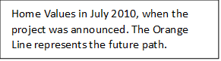
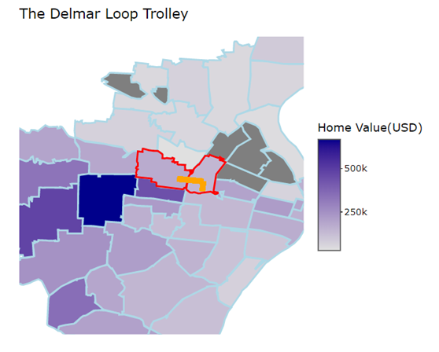
The primary dataset used for this analysis was Zillow.com research data, which includes a monthly index of typical home values for the nation’s zip codes, measured monthly. These observations go back to the year 2000, although this entire time period was not used for the study. I filtered the data to include information only on ZIP codes in the St. Louis metropolitan area, and then filtered the data for the two areas of interest: ZIP codes 63130 and 63112. In addition, for the purposes of selecting the appropriate control counties as well and producing figures like seen above, I used GIS(Geographic Information System) shapefile data and merged it with the Zillow data to produce the figure on the right, showing the typical home values in the area when the project was announced. It was from the figure on the right that the three control ZIP codes were chosen: 63114, 63108, and 63133. 63114 and 63133 are the two codes northwest of the treatment areas, and are north of the aforementioned Delmar Divide, meaning generally poorer. They are effective controls because they share similar demographics to the treated areas. 63108 contains another urban center, the Central West End, similar to the Delmar Loop in its walkability and mixed-use layout. The Central West End did not receive any part of the trolley. Typical data cleaning was used to make the data usable for both producing figures as well as creating the regression- the dataset was pivoted into a “long” format, so rather than each ZIP code being an individual observation, a “ZIP code-month” was. I ran four different regressions, with each being filtered by a different date range dependent on what the “treatment” date was. The reason for this decision is that it is not clear which point really serves as the inciting force for home value change; the project announcement, the start of construction, and the opening of the project can all be considered “treatments.” “If-else” statements were used to create dummy variables for the regression. In addition, the GIS shapefile was cleaned and read using the “rdgal” and “tidy” packages in R.
- Empirical Results
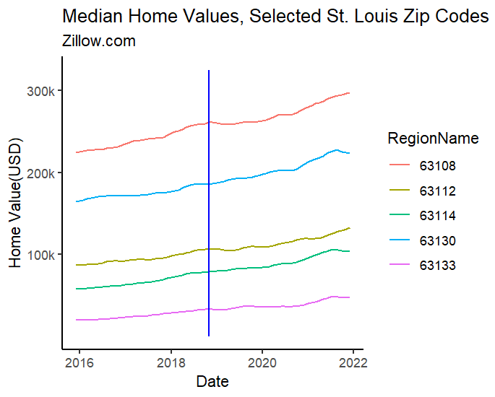
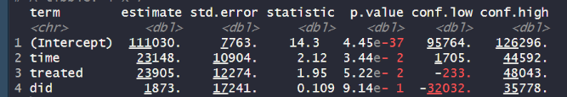
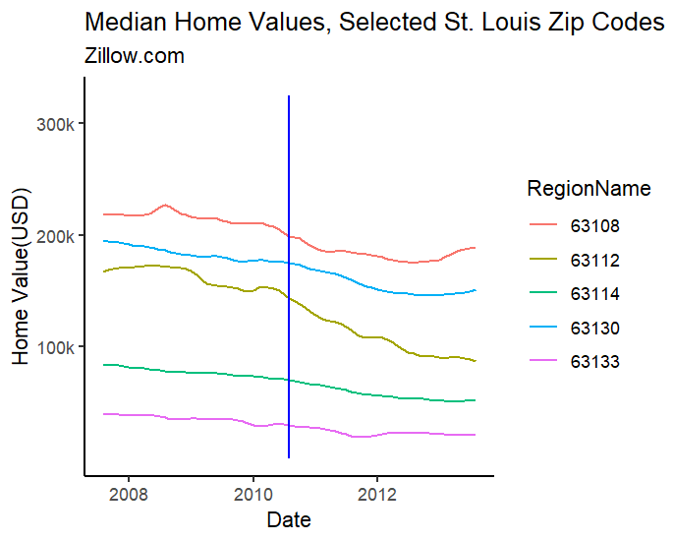
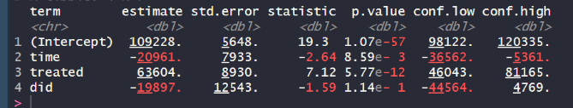
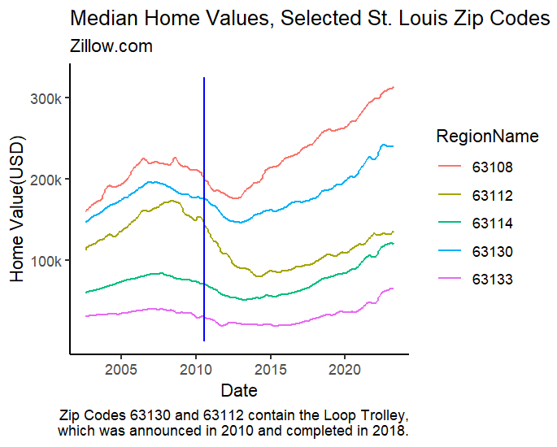
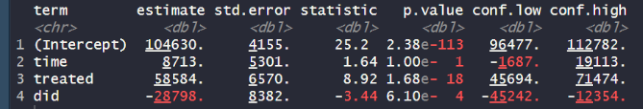
The first method I chose to examine was the date that the trolley opened, November 2018. A three year-window was selected on either side of this threshold date, meaning home values were considered from November 2015 all the way to November 2021. First, it was important to check the main assumption of difference in difference, that the treatment and control groups were on parallel trends prior to the date of interest. Looking at the figure to the left, it seems that this assumption is met. Keeping mind that 63130(light blue) and 63112(orange) are the treated areas, it seems visually that there is not a dramatic change in home value relative to the untreated areas after the trolley opened, represented by the blue line. The model results confirm the graph’s prediction, finding no significant difference-in-difference effect. As the regression summary table indicates, while a roughly $1800 increase in home values is found in the three-year period following the trolley’s opening relative to the control areas, a p-value greater than the 5% significance level and a confidence interval containing “0” indicates that the result is not statistically significant. Examining the trolley announcement date tells a similar story. The parallel trends assumption here is not met quite as well but is still reliable. According to this parameter, however, the treated areas received a $20,000 decrease in home values relative to the control areas. Again, this result is not statistically significant at the significance value of 5%. For the sake of brevity, I won’t include the figures for the test at the day that construction broke ground, because the results are almost exactly the same as the previous model. This model and the results are included in the code. The final period I wished to test is a wider period including the earlies complete data available, from around 2002, to the present day, with the announcement date in 2010 used as the treatment variable. Looking at the graph on the right, the parallel trends assumption seems to be tenuously met, with all areas following the same general trends (a post housing-crisis drop in home values) but at different rates. I continued with this analysis because of the general trend similarity. According to these results, the announcement of the trolley led to a nearly $30,000 decrease in home values relative to the control areas. And this result is significant; with a confidence level of 95%, the model says that there is a significant difference in home values between the treatment and control.
- Conclusion
The models run above do not indicate that the Loop Trolley led to an increase in home values in the ZIP codes in which the trolley was built. None of the four models found, with statistical significance, that home values increase in the years following the announcement, construction, and opening of the project, despite the claims of the FTA.
It is worth noting that the fourth model, which included a much larger date range and found a significant decrease in home values because of the project, is very likely invalid. Such a large time frame makes the analysis subject to a whole host of omitted variables. One such variable is that the selected ZIP codes vary in political administration. The western three areas fall primarily under St. Louis County government, while the eastern two are entirely within the City of St. Louis. The two governments have different goals and ideals and make different policy choices, and the wide time frame allows for differences in policy to have a larger and larger impact.
In addition, the project is significantly limited by technical restraints. ZIP codes are likely too large an area to make a precise estimate of the project’s effect on surrounding home values. Zillow does include more specific data, which breaks down average home value by neighborhood. While this could be useful, Zillow does not release boundary information (like the GIS shapefile) to create the necessary maps as seen above. A more-in depth analysis would use neighborhood boundary information to make the analysis more targeted.
The point of this analysis is to view urban circulators, like the Loop Trolley through a critical lens. The project has largely been seen as a failure because of low ridership, despite the hefty price tag that accompanied it. Many argue that the funds that were dedicated to the trolley could have been used to aid the city’s bus and rail system, which has faced budget issues recently despite providing a means of commute for thousands of St. Louisans. In the future, the economic effects of projects should be considered before tens of millions of dollars are committed to their construction.

Appendix
- Zillow Housing Data: https://www.zillow.com/research/data/
- GIS ZIP code boundary data: https://hub.arcgis.com/datasets/d6f7ee6129e241cc9b6f75978e47128b/explore?location=35.322414%2C-95.529164%2C4.40
References
Schlinkmann, Mark, "The return of St. Louis' Loop Trolley is set for April 27." St. Louis Post-Dispatch, 25 April 2021, https://www.stltoday.com/business/local/the-return-of-st-louis-loop-trolley-is-set-for-april-27/article_a452e413-f068-5c0b-9454-034e2b6eb560.html.

